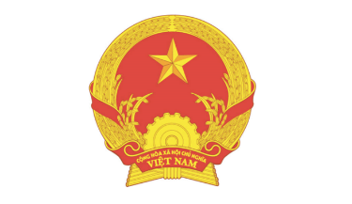  EMBASSY OF VIETNAM IN SWEDEN | MINISTRY OF INDUSTRY AND TRADE  OF VIETNAM |   MINISTRY OF ECONOMICS OF LATVIA | 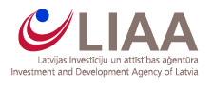  INVESTMENT AND DEVELOPMENT AGENCY OF LATVIA (LIAA)
TENTATIVE AGENDA
ONLINE FORUM
CONNECTING VIETNAMESE AND LATVIAN BUSINESSES

Date : Tuesday, 31st May 2022
Time (Vietnam) : 13h00 – 18h00
Time | Content
9:00 | Welcoming Speech  Mr. Do Thang Hai - Deputy Minister of Industry and Trade of Vietnam (MOIT)
9:10 | Speech  Mr. Edmunds Valantis - State Secretary of the Ministry of Economics of Latvia
9:20 | Speech  H.E. Mr. Phan Dang Duong - Vietnamese Ambassador to Sweden (concurrently Latvia)
9:25 | Speech  H.E. Ms. Maija Manika - Latvian Ambassador to China (concurrently Vietnam)
9:30 | An update of the Latvia trade policy, trade regime, rules and regulations with a particular respect to the most important trade items between Vietnam and Latvia  Mr. Kaspars Abiks, Head of the Export Promotion Division at the Investment and Development Agency of Latvia (LIAA)
9:50 | Bilateral trade between Vietnam - Latvia and prospects for businesses of both sides  Ms. Nguyen Thao Hien – Deputy Director of European – American Market Department (MOIT)
10:10 | Opportunities to develop Vietnam – Latvia relations in the fields of agricultural products and food processing  Mr. Le Thanh Hoa – Deputy Director General, Agro Processing and Market Development Authority, MARD
10:30 | Cooperation opportunities in woodworking sector  Ms. Ieva Erele – Executive Director of the Furniture Producers Association in Latvia
10:45 | Q&A
11:50 - 12:00 | Conclusion  VIETRADE
12:00 - 14:00 | B2B section  Moderated by LIAA
Time (Latvia) : 09h00 – 14h00

